**Southern Song Dynasty Mirror from Xanadu, ca. 1279 CE**

**This Southern Song (南宋, 1127–1279) bronze mirror has an interesting story because it reflects the takeover of China by Kublai Khan, the first non-Chinese Emperor.**

**The mirror was cast in Xuzhou (徐州) a major city in Jiangsu province in central east China on the Huai Ho river but it was found in the Mongol stronghold of the Kublai Khan in the Minusinsk Basin. How did this mirror come to reside with the Mongols?**

**The answer is partly climatic and partly political. Because the Huai Ho river does not empty into the China sea, the area of Xuzhou was subject to seasonal flooding. This was exacerbated due to the Asian version of the Neo-Atlantic Altithermal Climatic Period, 800-1250 CE. Rainfall increased, the growing season was lengthened with a warming trend and population expanded. As a result of the increased rainfall, the Huang Ho river silted up, changed its course and flowed into the lower Huai River inundating the valley near Xuzhou. The land became barren due to flooding, nutrient depletion and salination .**

**Concurrently, the Jin Dynasty to the north also experienced a population explosion and took control of northern China. Close on the heels of the Jin were the Mongols under Möngke Khan (1209 –1259) who conquered the Jin and took control of northern China in 1234. When Möngke Khan died, his younger brother, Kublai Khan (1215-1294), grandson of Genghis Khan, succeeded him. In 1271 Kublai Khan was proclaimed the Emperor of China and eight years later he conquered the Southern Song Dynasty.**

**Prestige goods like this mirror flowed north to Kublai Khan's capital, Xanadu, in what is now Inner Mongolia, 275 km (171 mi) north of Beijing. This mirror attests to Kublai Khan's appreciation of key treasures of the Southern Song Dynasty to enhance his court.**

**The mirror displays typical signs of Southern Song mirrors: it is thin with a raised border and has two vertical Chinese inscriptions placed within two frames. An exact duplicate is in the Minusinsk Museum.**

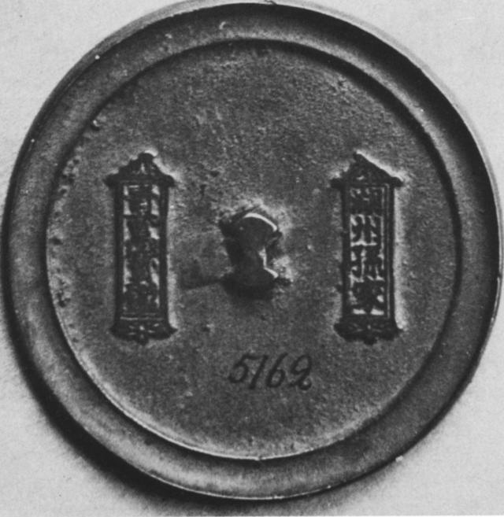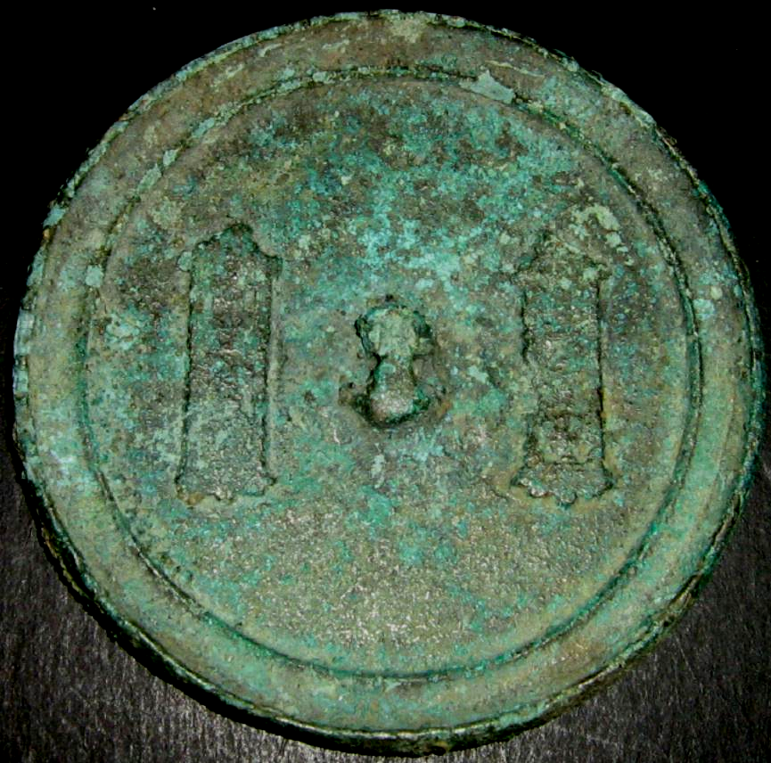

**Mirror with inscription, Diam. 8 cm. ca. 1279 CE. Found in Minusinsk Basin. Left: *Minusinsk Museum*; right Atlantica Coll. Refs.: Wang Shih-lun, "T'an-t'an Hu-chou ching,"  *Wenwu,* 1958, no.6; E. Loubo-Lesnitchenko, Imported Mirrors in the Minusinsk Basin, Artibus Asiae, Vol. 35, No. 1/2 (1973), pp. 25-61.**